|  |  |  |  |
| --- | --- | --- | --- |
| **Student’s name** | …………………………………………………….…… | **Grade** | **4** |
| **Subject** | **Computer** | **Week No.** | **3** |
| **Lesson Title** | **Network Connections** | **Unit** |  |

**Worksheet No. ( 3 )**

**write the correct name of each part**.

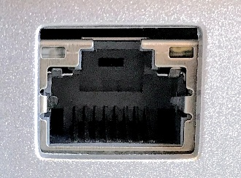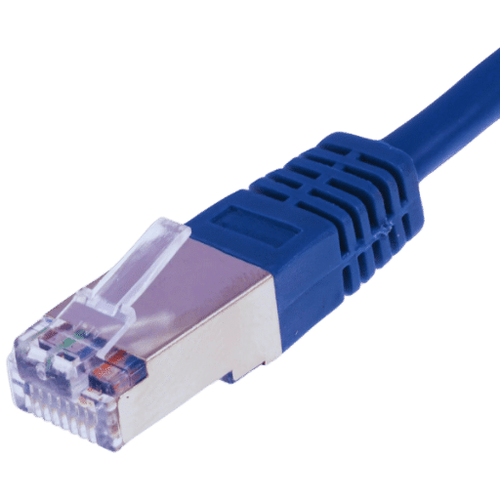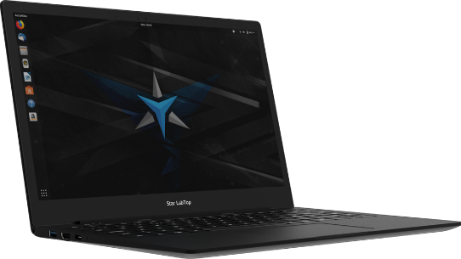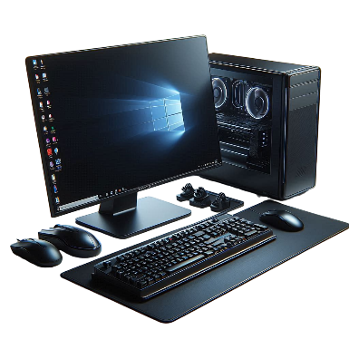

Ethernet Port

Ethernet Cable

Laptop

**Good Luck**

CPU